**AIM: IMPLEMENTATION AND ANALYSIS OF CLUSTERING ALGORITHMS LIKE K-MEANS**

**THEORY:**

K-medoids clustering is a variant of K-means that is more robust to noises and outliers. Instead of using the mean point as the center of a cluster, Kmedoids uses an actual point in the cluster to represent it. Medoid is the most centrally located object of the cluster, with minimum sum of distances to other points.

The group of points in the right form a cluster, while the rightmost point is an outlier. Mean is greatly influenced by the outlier and thus cannot represent the correct cluster center, while medoid is robust to the outlier and correctly represents the cluster center. It is a clustering algorithm resembling the K-Means clustering technique. It falls under the category of unsupervised machine learning. It majorly differs from the K-Means algorithm in terms of the way it selects the clusters’ centres. The former selects the average of a cluster’s points as its centre (which may or may not be one of the data points) while the latter always picks the actual data points from the clusters as their centres (also known as ‘exemplars’ or ‘medoids’). K-Medoids also differ in this respect from the K-Medians algorithm which is the same as K-means, except that it chooses the medians (instead of means) of the clusters as centres

**SOURCE CODE:**

1. **IMPORTING LIBRARIES & READING DATASET:**

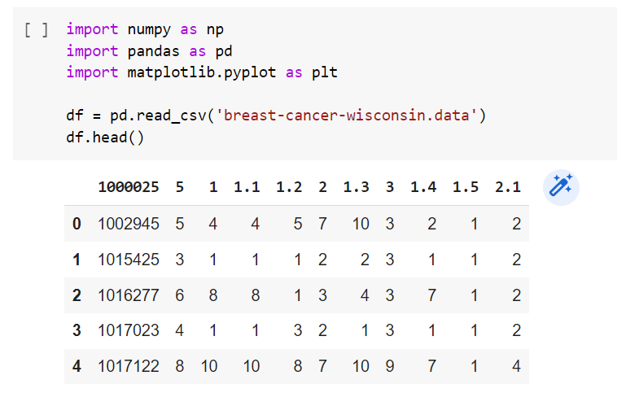

1. **DATA PREPROCESSING:**

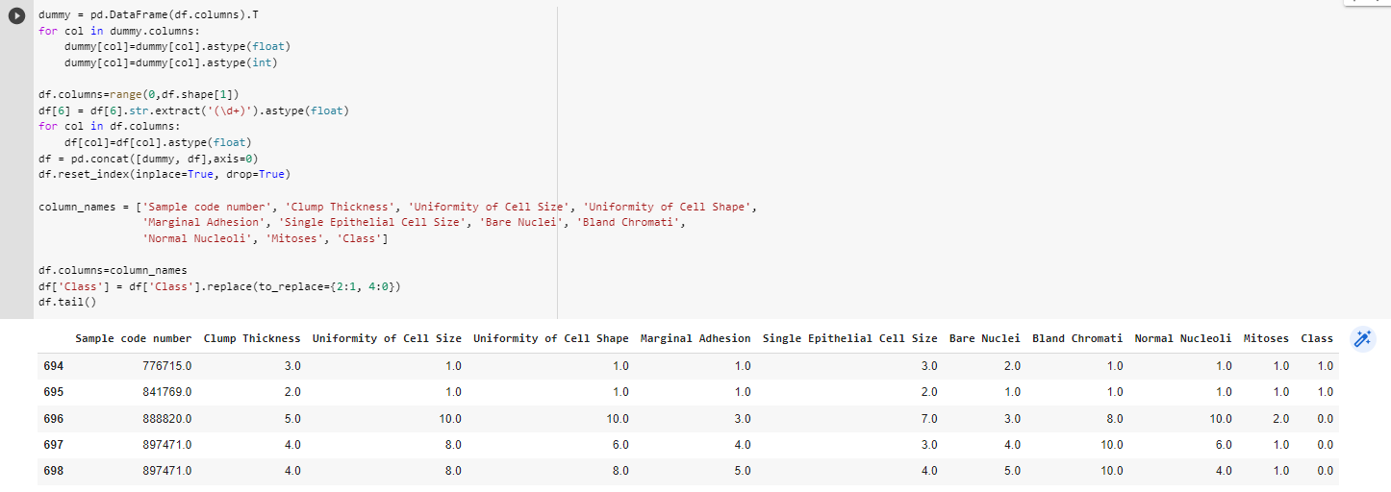

1. **COUNT OF NULL VALUES:**

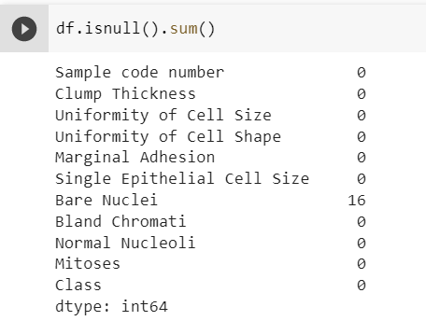

1. **DROPPING NULL VALUES:**

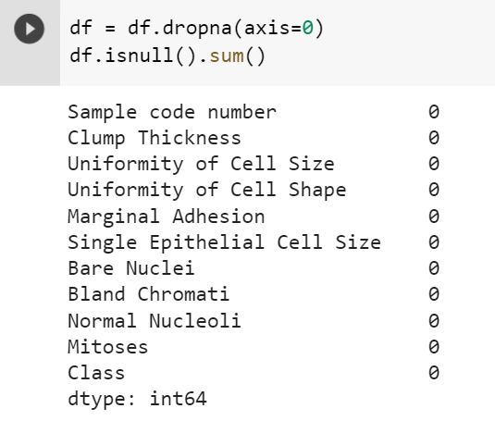

1. **NORMALIZATION:**

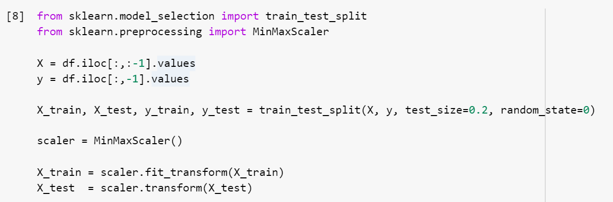

1. **INSTALLING & IMPORTING LIBRARIES FOR KMEDIOD:**

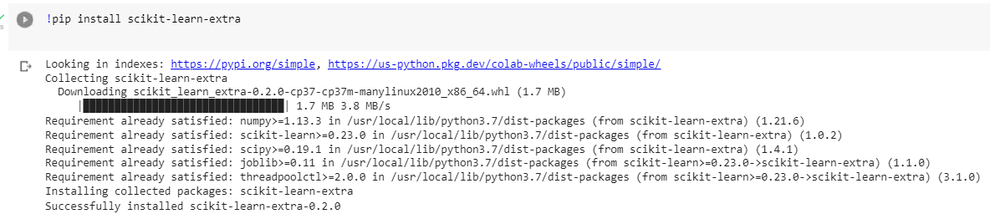

1. **BUILDING MODEL OF K-MEDIOD & PREDICTION OF BREAST CANCER:**

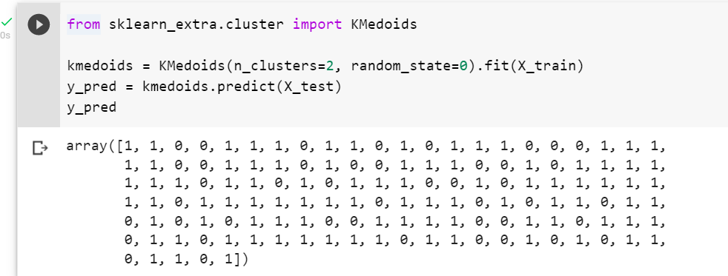

1. **CONFUSION MATRIX:**

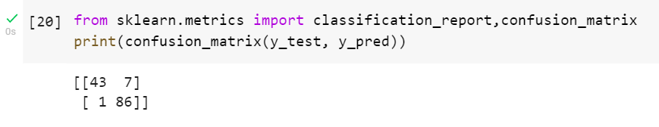

**CONCLUSION:**

From this practical, I have learned the implementation of k-medoid in python.